Task 1 : Design and Configure the AWS Networking Infrastructure
Create the networking components required for the application.
Tasks
Create the following AWS resources:
- Custom VPC
- Internet Gateway
- NAT Gateway
- Elastic IP
- Route Tables
- Subnet Associations
VPC
Create a VPC using an appropriate CIDR block.

Subnets
Create 6 Subnets distributed across 2 Availability Zones.
Subnet Type | Quantity
Public (Web Tier) | 2
Private (Application Tier) | 2
Private (Database Tier) | 2
Each subnet should support at least 256 IP addresses.

Internet Gateway
- Create an Internet Gateway.
- Attach it to the VPC.
NAT Gateway
- Allocate an Elastic IP.
- Create a NAT Gateway in one of the Public Subnets.
- Ensure private resources can access the Internet through the NAT Gateway.

Route Tables
Create 3 Route Tables.
Route Table | Associated Subnets
Public Route Table | Public Subnets
Private Application Route Table | Application Subnets
Private Database Route Table | Database Subnets
Configure appropriate routes and subnet associations.

  - VPC 10.0.0.0/16

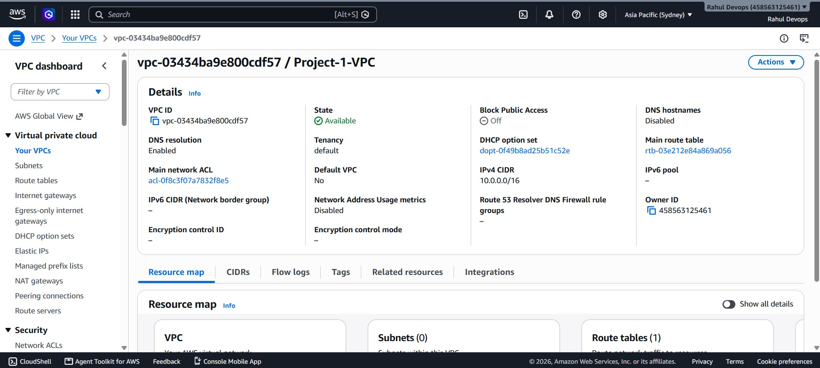

  - Internet Gateway

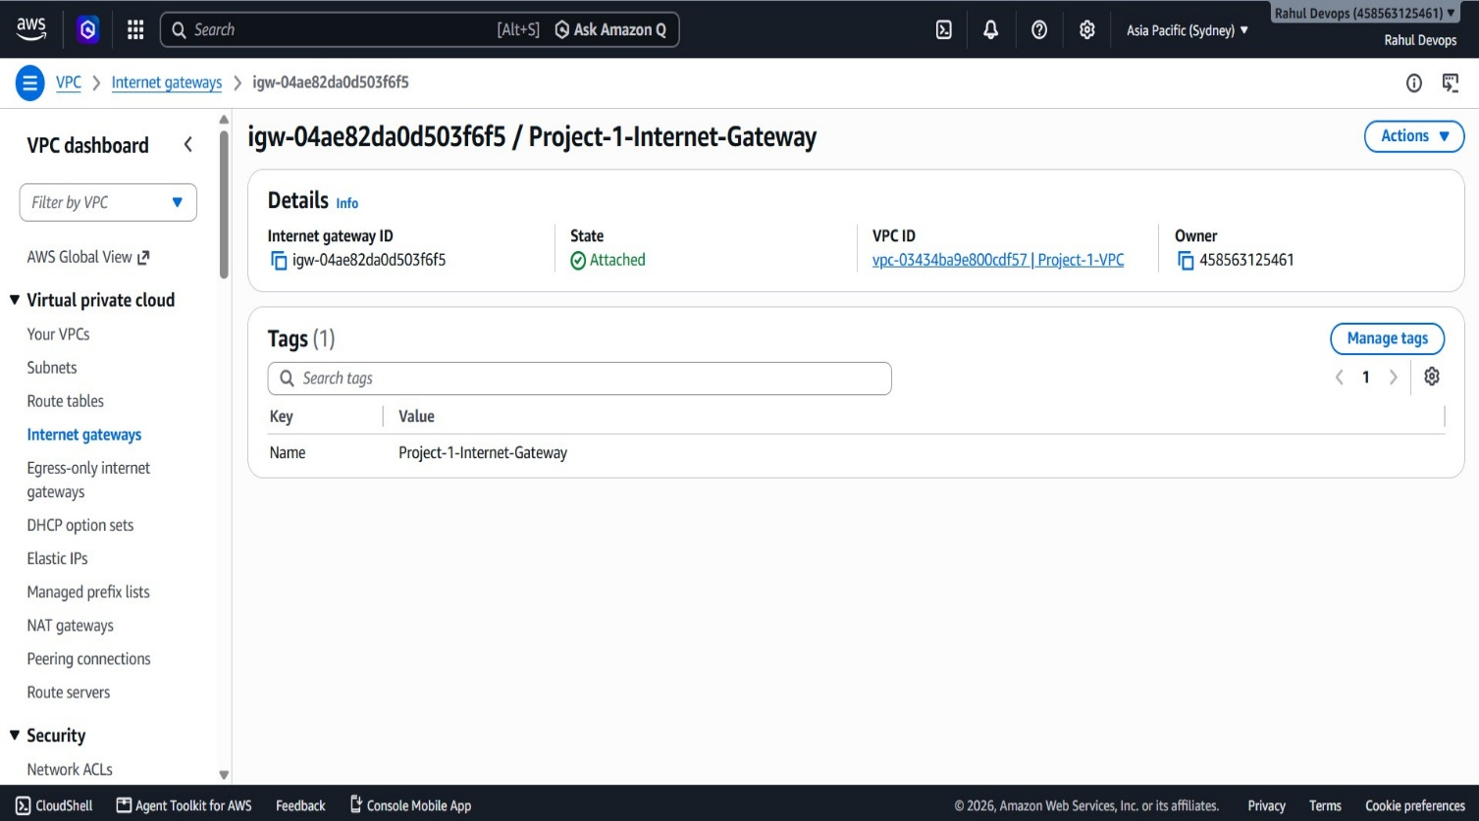

  - NAT Gateway

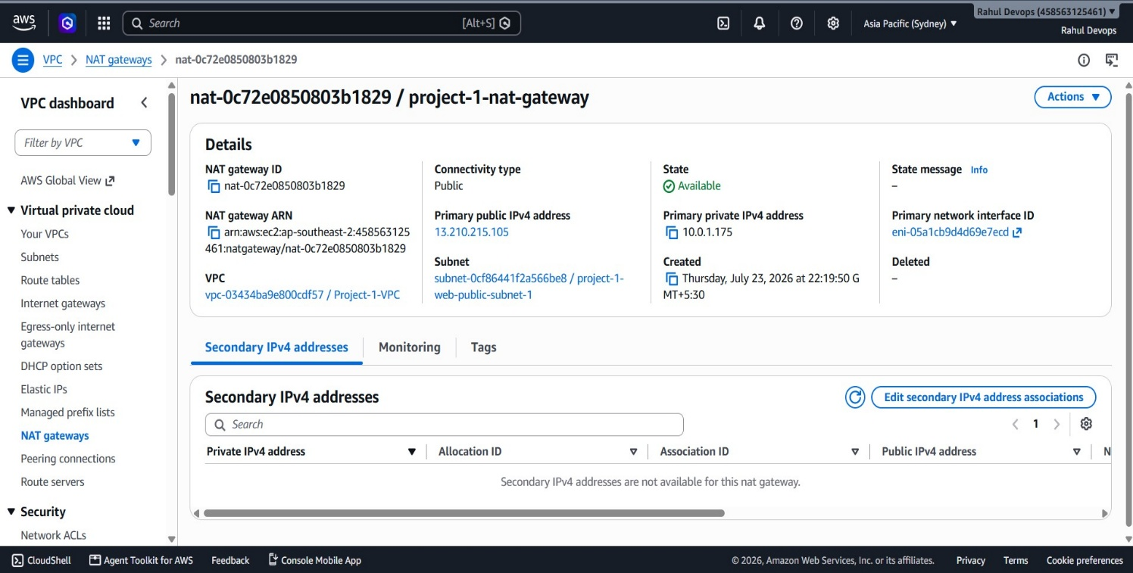

  - Elastic IP

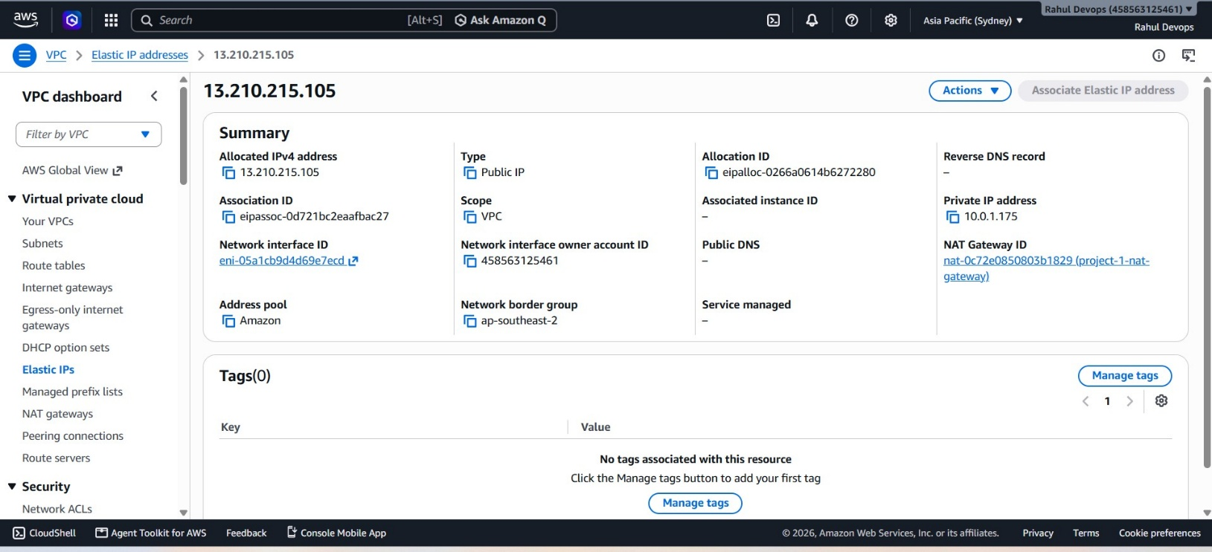

  - Public Subnet 1: Web Server 10.0.1.0/24

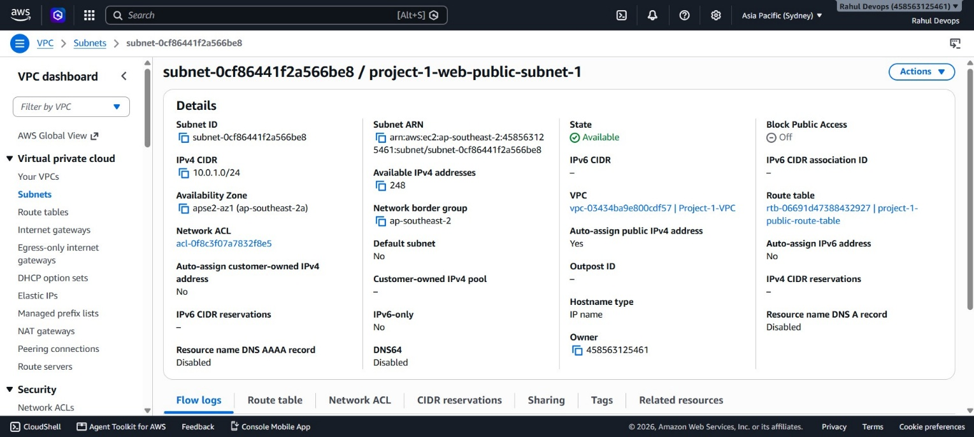

  - Public Subnet 2: Web Serve Server 10.0.2.0/24

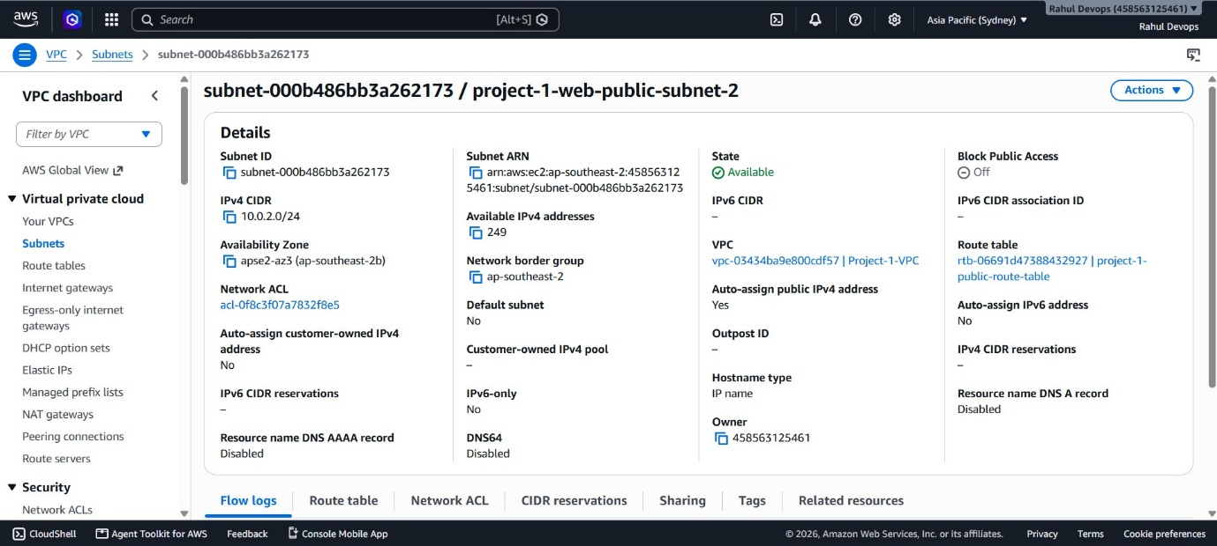

  - Private Subnet 1: Application Serve Server 10.0.3.0/24

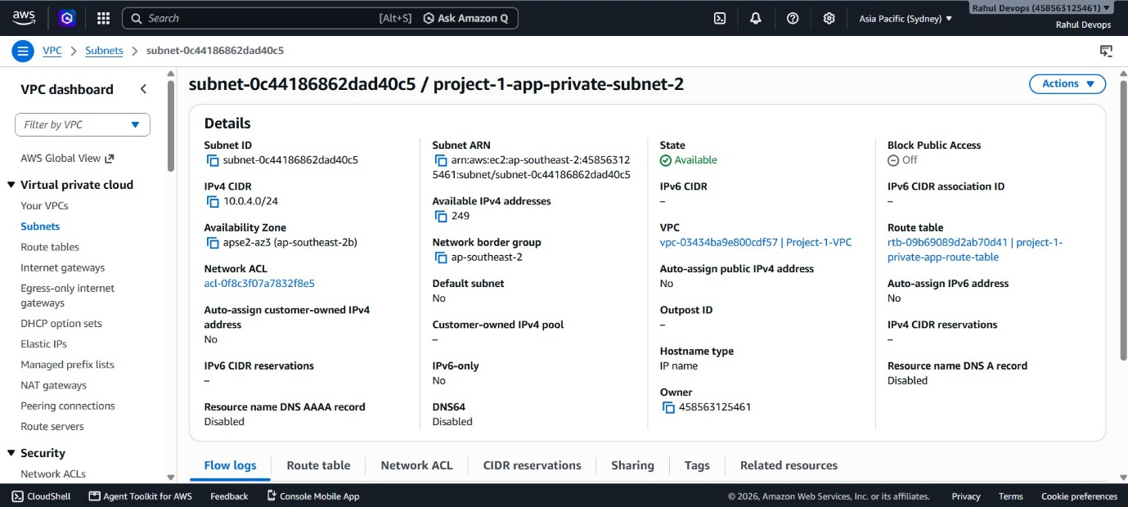

  - Private Subnet 2: Application Serve Server 10.0.4.0/24

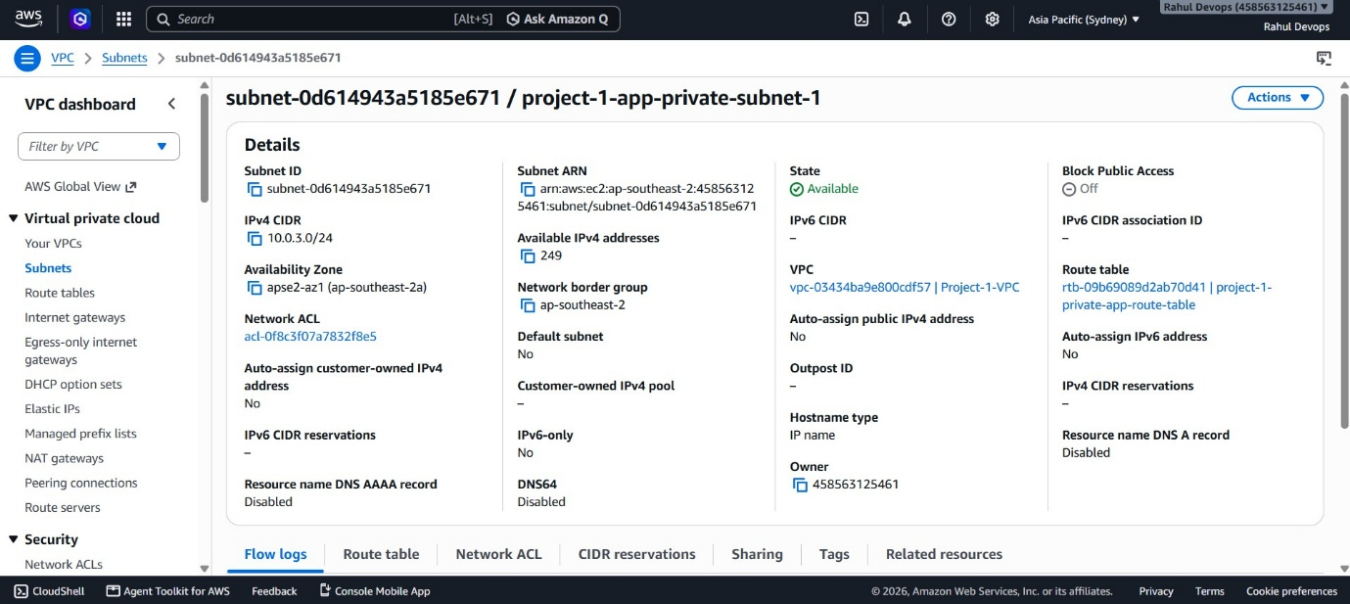

  - Private Subnet 1: Database Serve Server 10.0.5.0/24

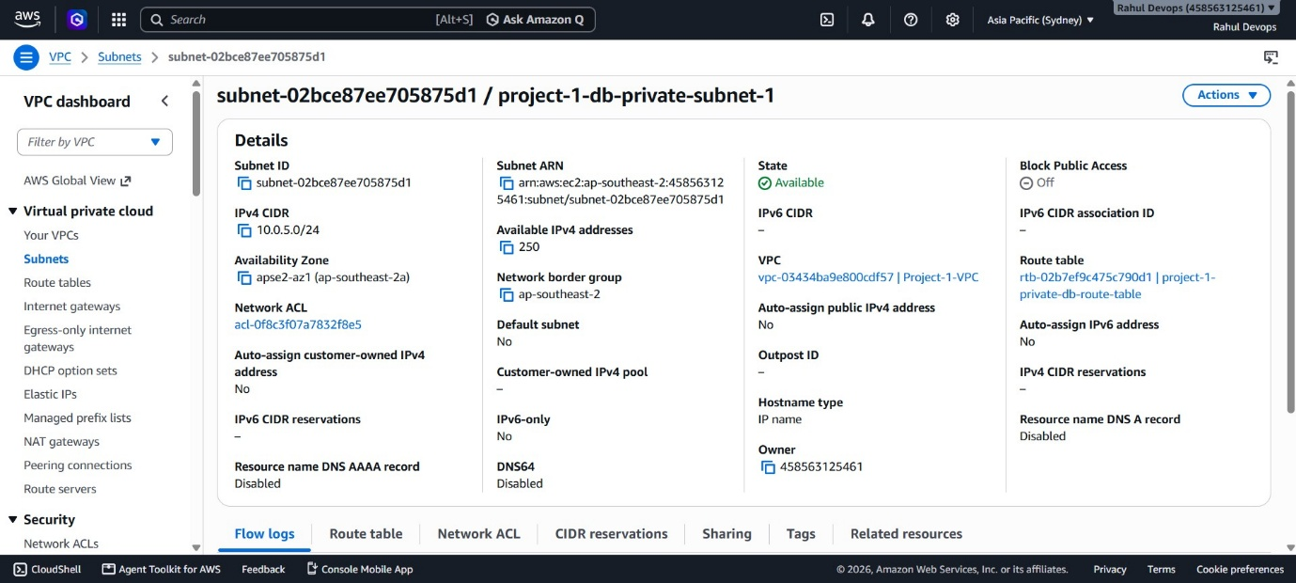

  - Private Subnet 2: Database Serve Server 10.0.6.0/24

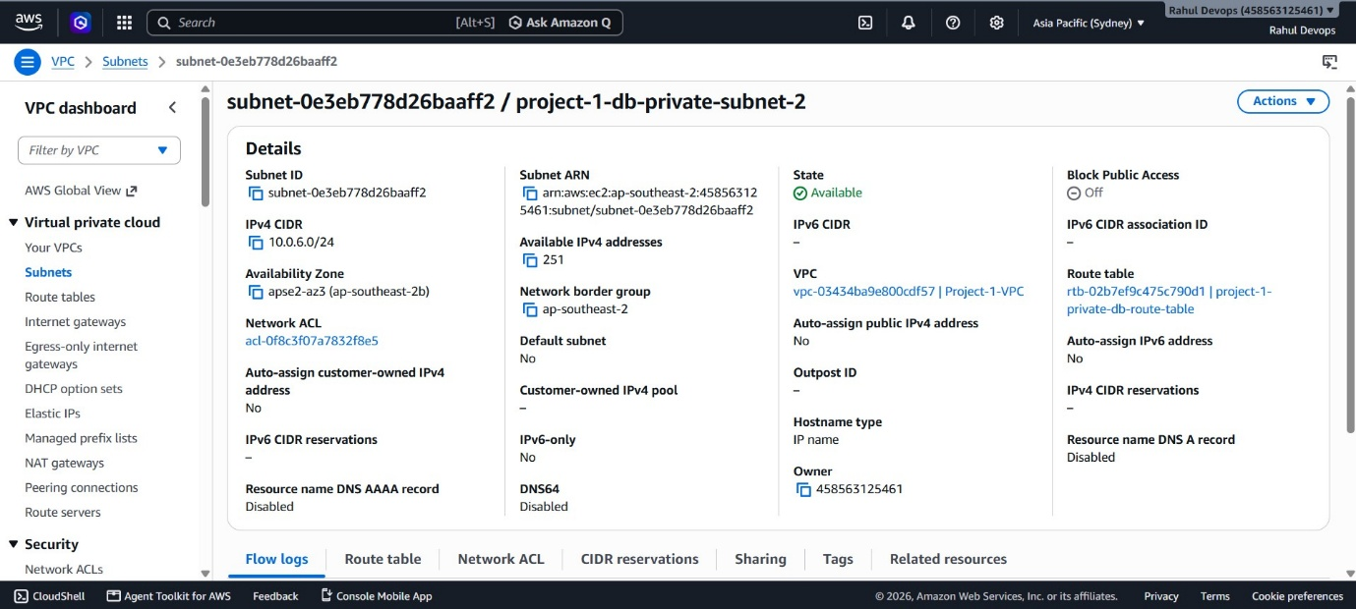

  - Public Route table with Routes

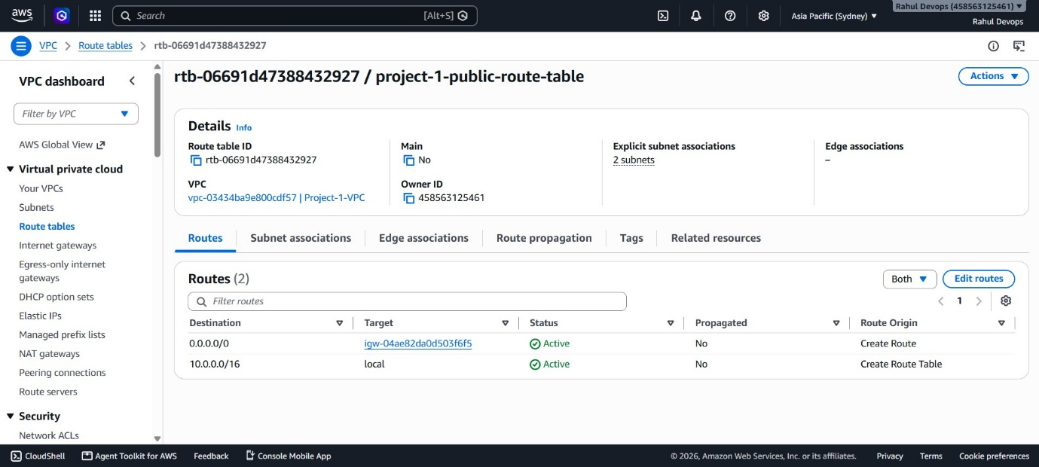

  - Public Route table with public web subnet associated with it

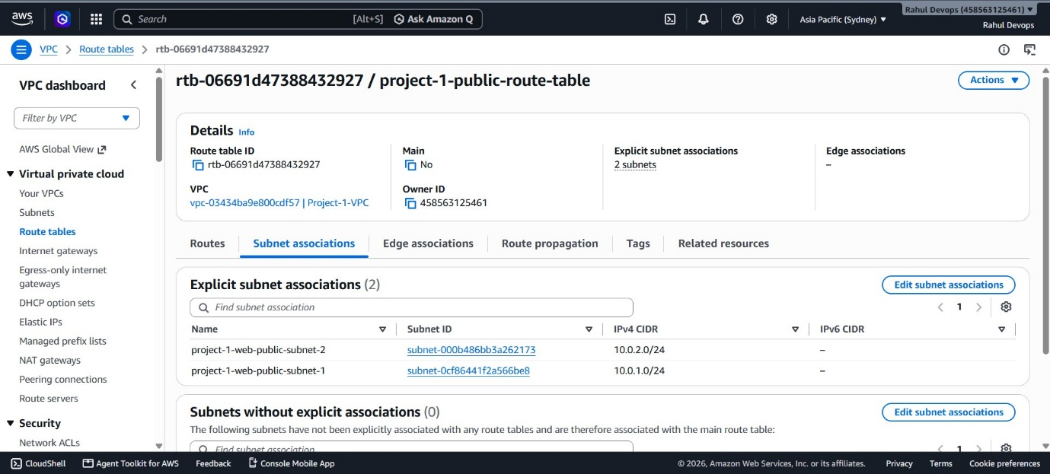

  - Private App Route table with Routes

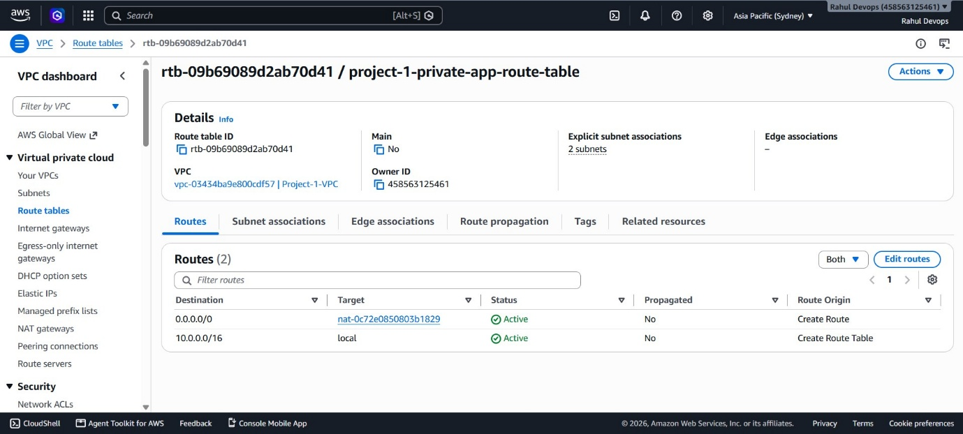

  - Private Route table with private app subnet associated with it

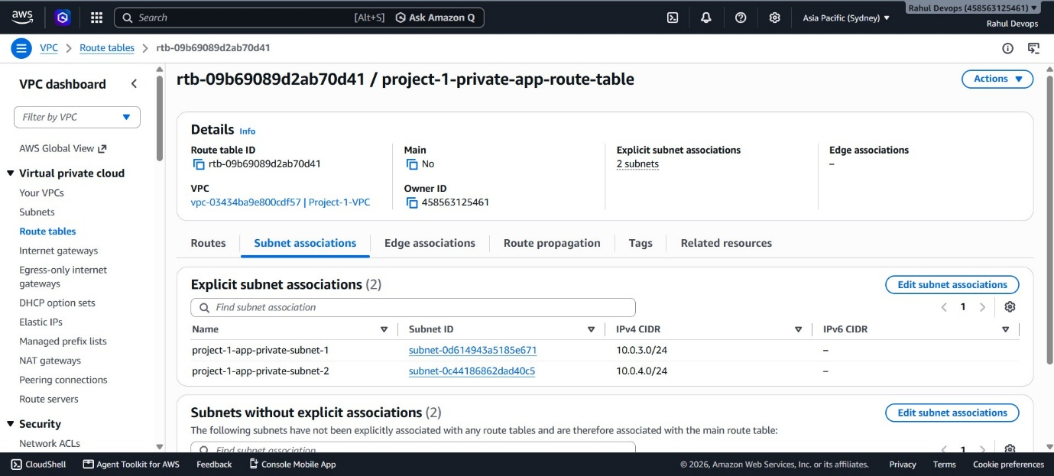

  - Private Database Route table with Routes

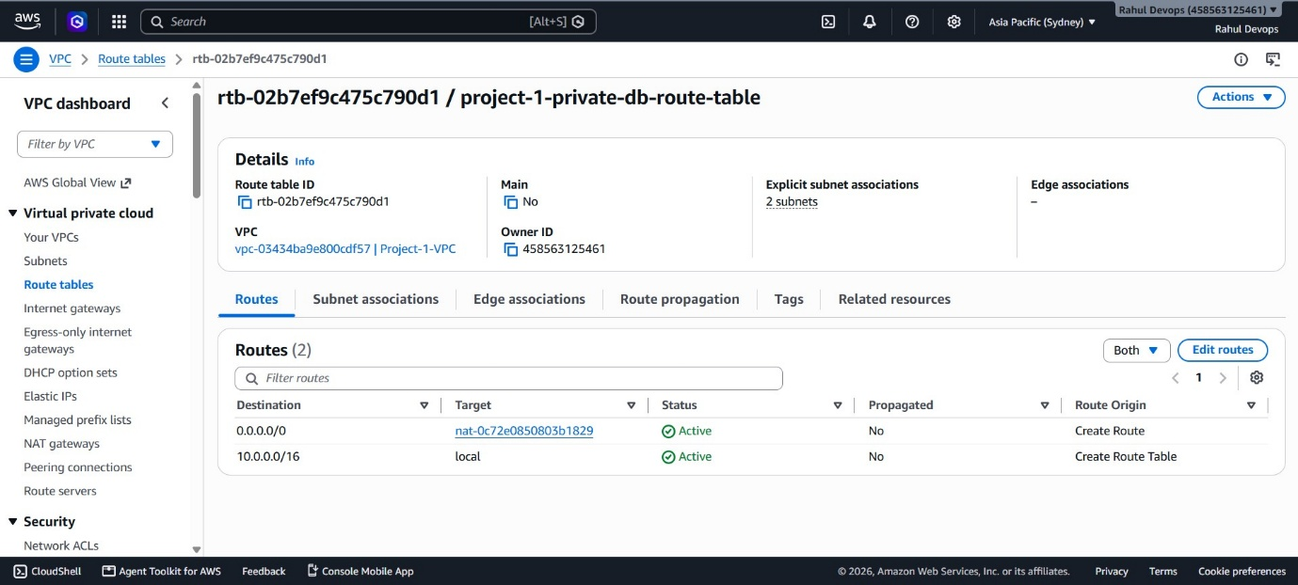

  - Private Route table with private DB subnet associated with it

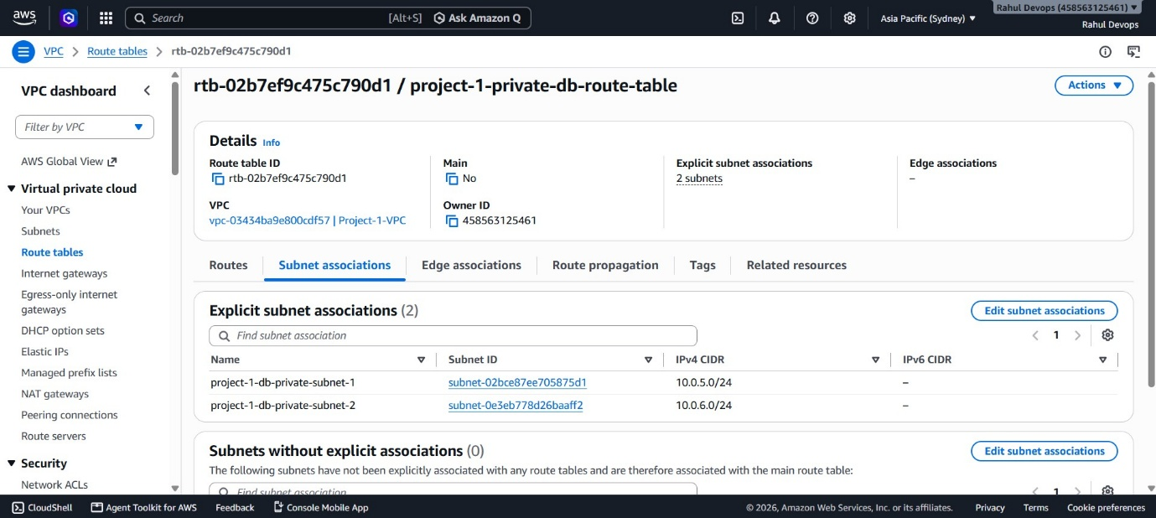

  - Public Security Group

